**DAILY ONLINE ACTIVITIES SUMMARY**

|  |  |  |  |  |  |  |  |  |
| --- | --- | --- | --- | --- | --- | --- | --- | --- |
| **Date:** | 02/07/2020 | | | | | **Name:** | RIYA CP | |
| **Sem & Sec** | IV sem & B section | | | | | **USN:** | 4AL18CS70 | |
| **Online Test Summary** | | | | | | | | |
| **Subject** | | **-** | | | | | | |
| **Max. Marks** | | 30 | | **Score** | | | **-** | |
| **Certification Course Summary** | | | | | | | | |
| **Course** | Blockchain Basics | | | | | | | |
| **Certificate Provider** | | | Great learning academy | | **Duration** | | | 2.5hours |
| **Coding Challenges** | | | | | | | | |
| **Problem Statement1:** Write a Java Program minimize the maximum difference between adjacent elements in an array. | | | | | | | | |
| **Status: Executed** | | | | | | | | |
| **Uploaded the report in Github** | | | | | YES | | | |
| **If yes Repository name** | | | | | lockdown-coding | | | |
| **Uploaded the report in slack** | | | | | YES | | | |

**Online Test Summary:** No internals conducted today.

**Online Certification Course Summary:** Today I have completed the course and attempted the quiz to get the certificate.

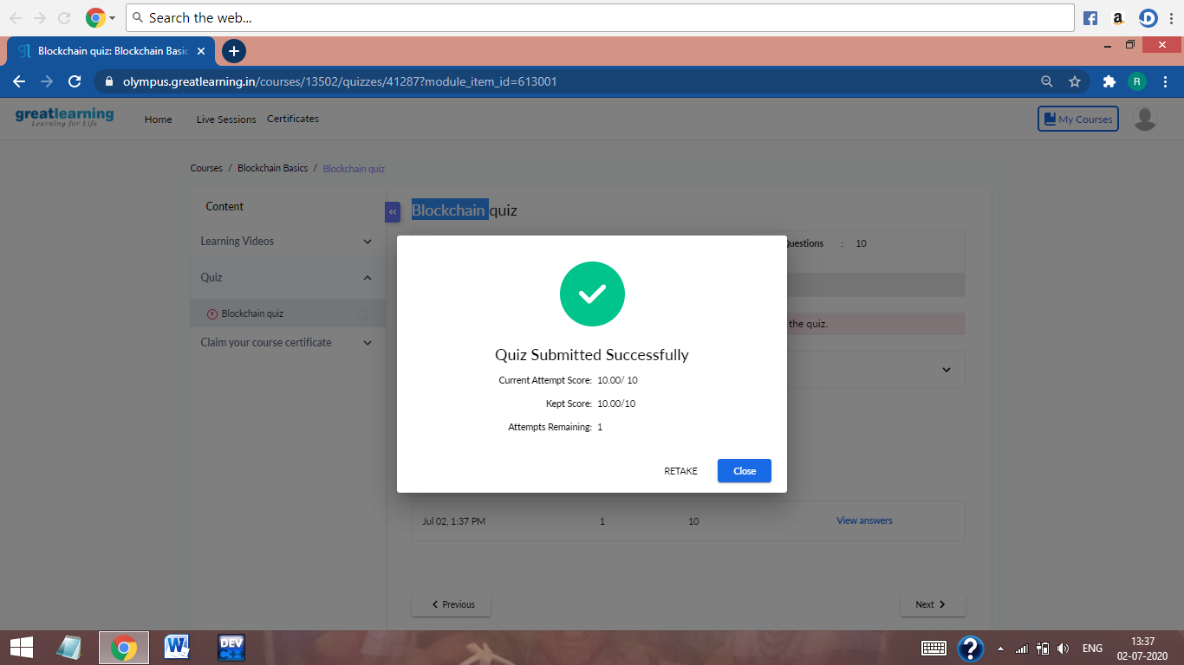

This is the Snapshot of the quiz attempted and grade obtained.

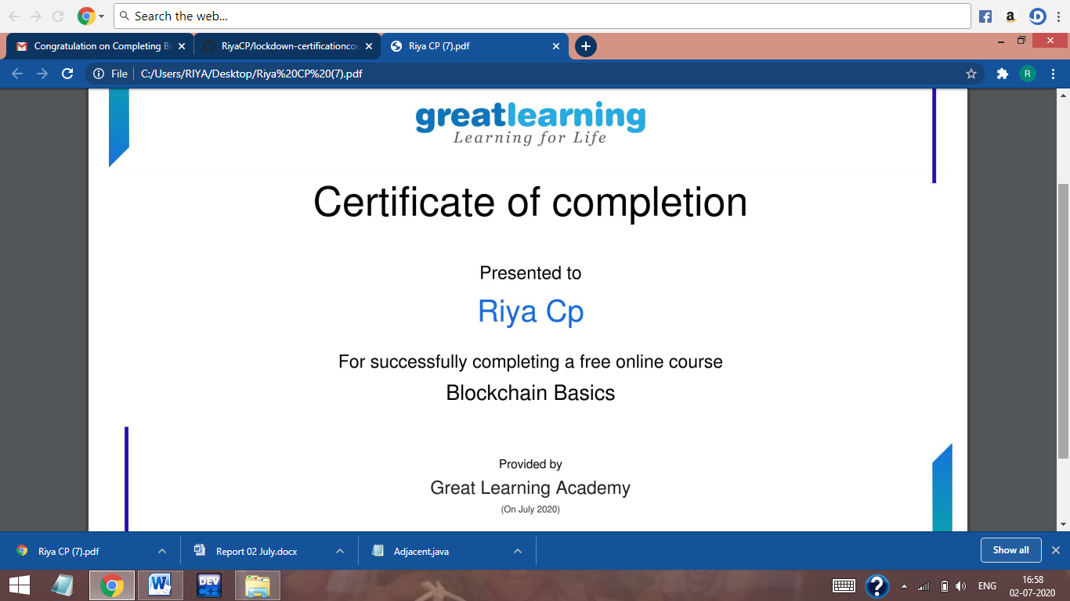

This is the Snapshot of the certificate of completion.

**Online Coding Summary:** Today I had received one program from prof. Shilpa CSE Dept. The program is mentioned above in the coding challenges (pg.01). I have also uploaded it to my Github repository.

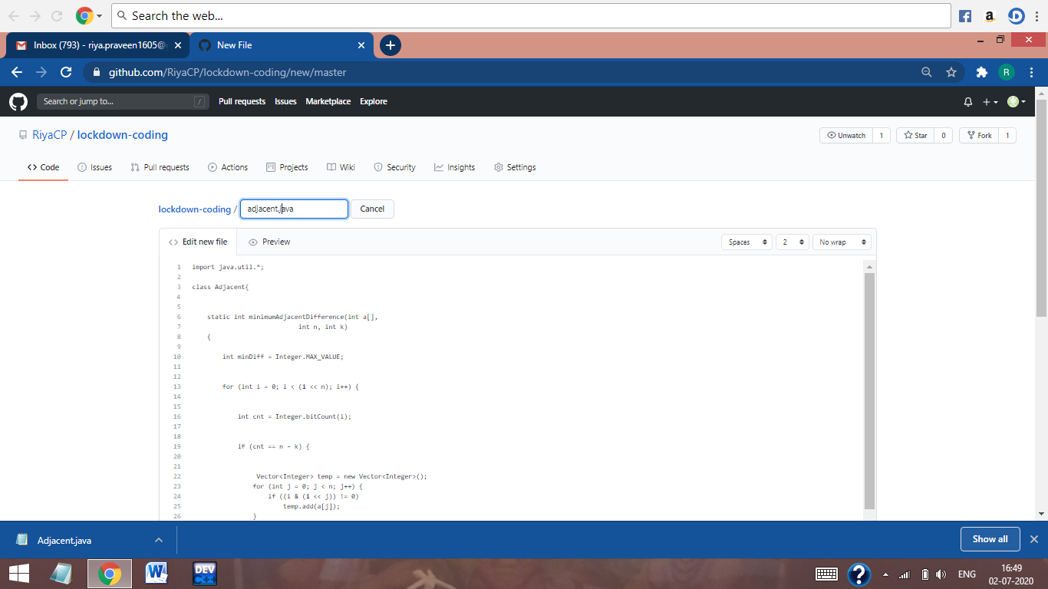

This is the Snapshot of my Github repository were I have uploaded the code. File name is Adjacent.java

**Online Training:** Today I had attended the online training organized by CSE Department AIET. The training was on C++ programming language done by Prof. Shruthi Shetty J. CSE Dept. After the session the quiz was conducted.

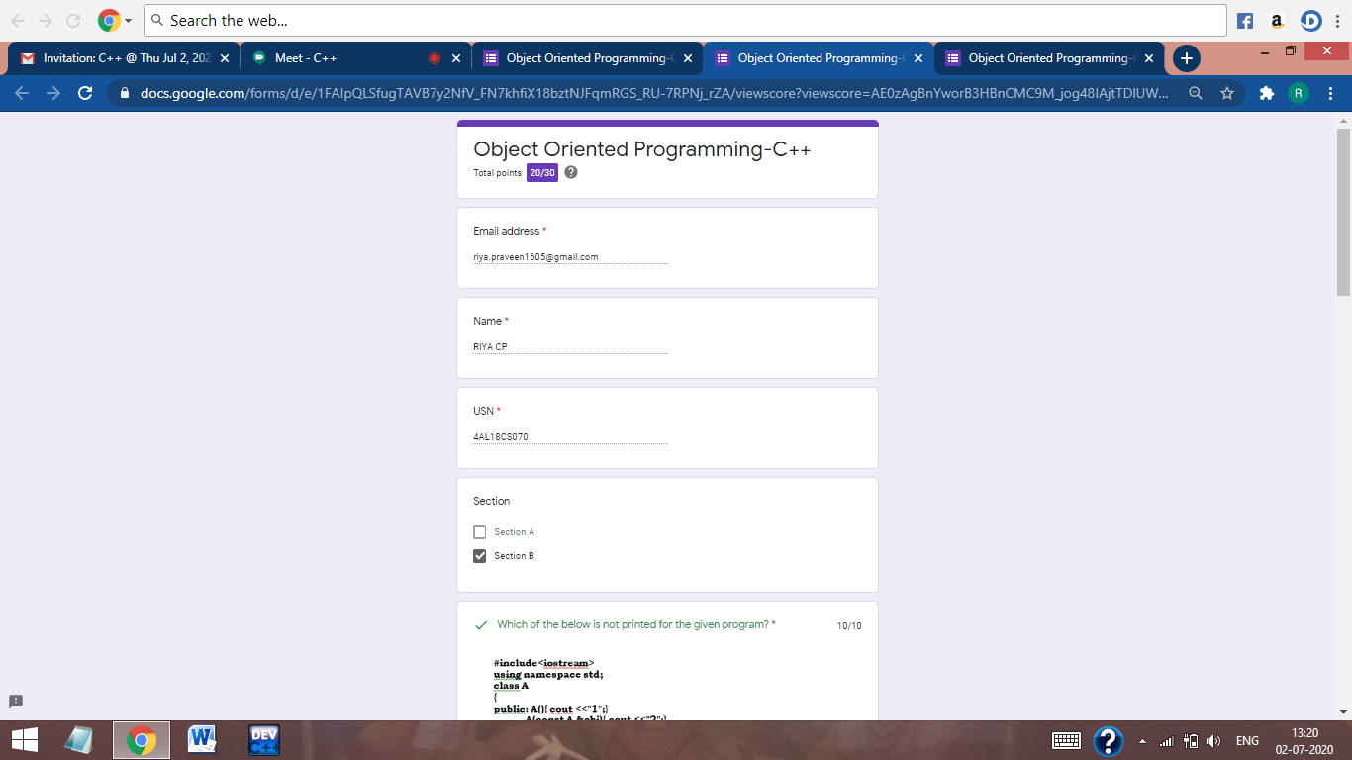

This is the Snapshot of the quiz attempted and scores obtained.